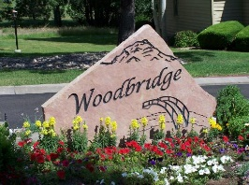
Application for Exterior Alteration or Architectural Design Modification

Woodbridge TOWNHOME OWNERS Association
c/o Warren Management Group
1720 Jet Stream Drive, Suite 200
Colorado Springs, CO 80921
Phone (719) 685-7848 Fax (719) 534-9177
skouri@warrenmgmt.com
Please remember the committee has 30 days to respond to your request.

Homeowner Name: Date Submitted:

Home Address: Woodbridge Dr.

Home Phone: Work Phone:

Description of Improvement or Modification:

Color Scheme (if applicable):

Location on Property (if applicable):

Type of Construction Material (if applicable):

Signature:

Note: Attach a sketch of all improvements or modifications showing location and dimensions. Please include manufacturer’s name, color and the window or door style. If you have questions, contact Association Manager - Steve Kouri. Please submit form to Steve Kouri.

Date Received: Received by:

Date Reviewed: Reviewed by:

Recommendations:

Request Approved: Date:

Request Approved subject to the following:

_______________________________________________________________________________________

Request Disapproved: Date:

Reasons for Disapproval and suggested modification:

